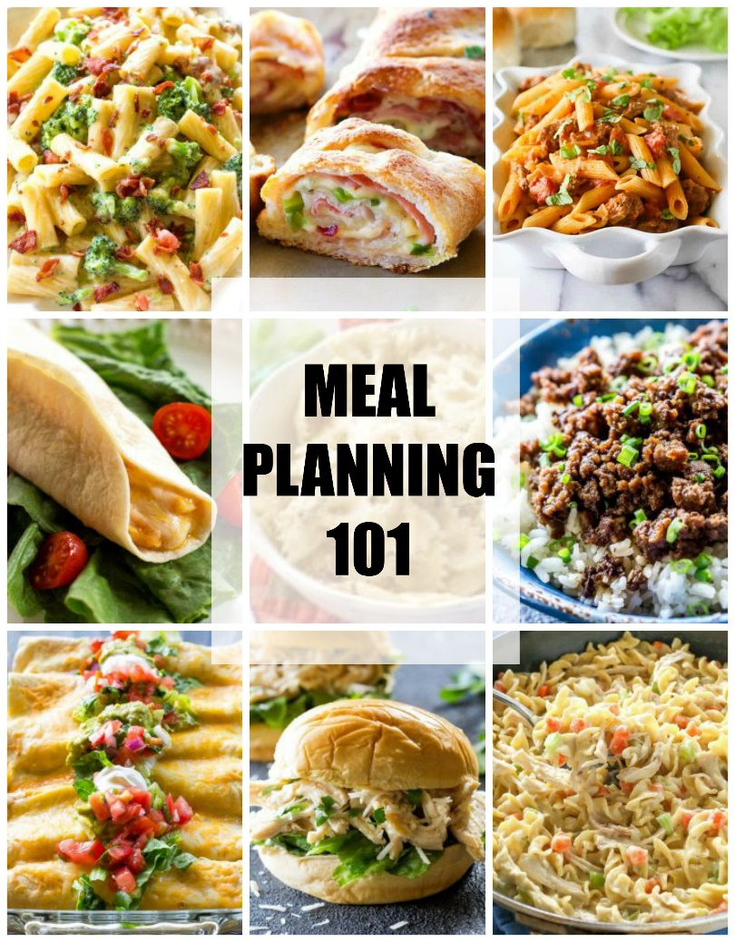

MEAL PLANNING 101
- How many meals do you need to plan for? Look at your week and commitments and see what nights you’ll be eating at home.
- Do you have any time constraints? Busy day might call for a crockpot meal.
- Write a grocery list. Try to buy ingredients you can use in multiple recipes a week. Make inventory of what you already have so you don’t buy it again and waste money.
- Shop for ingredients. Have a designated shopping day.
- Prepare those ingredients. Cook ground beef all at once and freeze in bags (1 pound per bag) to save time. Cook a big batch of chicken, shred, and freeze in bags (2 cups per bag).
- Use freshest ingredients at the beginning of the week.
- Double up. Make recipes that will have leftovers and freeze them for a rainy day.
- Have a theme night. It takes the guesswork out if Monday is always Italian, Tuesday is Taco Tuesday, etc.

MEAT TIPS

Buy ground beef in bulk and separate into 1 pound bags to freeze. You can even go the extra mile and brown and crumble the beef and then separate it into Ziploc bags to freeze for an easy dinner.

Cook a big batch of chicken in a slow cooker on low heat in about a cup of water or chicken broth. Shred it and separate into Ziploc bags with 2 cups of chicken in each bag and freeze. Thaw to add into any of these recipes.

Costco sells a big bag of rotisserie chicken. Separate into Ziploc bags with 2 cups of chicken in each bag and freeze.

For an always updating list of easy recipes go here:

https://www.the-girl-who-ate-everything.com/category/super-easy-recipes/

Creamy Sausage and Tomato Pasta

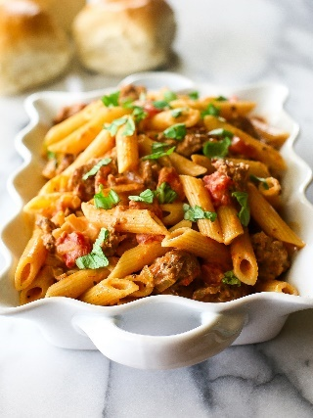
Creamy Sausage and Tomato Pasta is one of my favorite Italian dinners to make for my family! The spicy sausage, garlic, tomatoes, cream, and basil may be simple ingredients but they blend together so well in this Creamy Sausage and Tomato Pasta.

Total Time 25 minutes
Yield 6 servings

Ingredients
- 1 pound Italian sausage
- 1 cup chopped onion
- 3 cloves garlic, minced
- 1 (14.5 ounce) can Italian style diced tomatoes
- 1 (8 ounce) can tomato sauce
- 1 cup heavy cream
- 5-6 big leaves of fresh basil, chopped
- 12 ounces penne pasta (get a 16 ounce box and use 3/4 of it)
- grated Parmesan for topping

Instructions
- Cook the pasta in salted water al dente, according to package directions.
- While pasta is cooking, brown and crumble the sausages like you would ground beef.
- Add the onions and garlic to the sausage and saute for a couple of minutes.
- Pour in the entire can of diced tomatoes and the tomato sauce and heat through.
- Pour in the cream and heat through. The longer you cook the sauce the thicker it will get so simmer it until it is the consistency you want.
- Add the fresh basil and let it simmer for a few minutes.
- Finally, mix the sausage sauce with the pasta and serve. Top each serving with a sprinkle of Parmesan cheese. Serve with crusty garlic bread.

Ham and Swiss Stromboli
This five ingredient Ham and Swiss Stromboli is filled with ham, Swiss cheese, bacon and green onions. The combo of flavors is delicious. This is a dinner I make when we have a busy schedule because it’s so easy.
Yield 8 servings
Total Time 40 minutes

Ingredients
- 1 tube (11 ounces) refrigerated crusty French loaf
- 6 ounces thinly sliced deli ham
- 3 green onions, sliced
- 8 bacon strips, cooked and crumbled
- 1-1/2 cups (6 ounces) shredded Swiss cheese (see note)

Instructions
- Preheat oven to 350°. Unroll dough into a rectangle on a greased baking sheet. Place ham over dough to within 1/2 inches of edges of the dough; sprinkle evenly with onions, bacon and cheese. Roll up jelly-roll style, starting with a long side. Pinch seam to seal and tuck ends under. Place seam side down on baking sheet.
- With a sharp knife, cut several 1/4-in.-deep slits on top of loaf. Bake 20-30 minutes or until golden brown. Cool slightly before slicing. Serve warm.

Recipe Notes
You can also use sliced swiss cheese. It makes it a little harder to roll but works just as well!

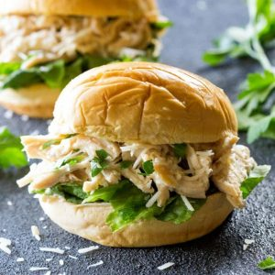
Slow Cooker Chicken Caesar Sandwiches

Slow Cooker Chicken Caesar Sandwiches are my favorite recipe to feed a crowd

Yield 6 servings

Total Time 4 hours 10 minutes
INGREDIENTS
- 2 pounds boneless skinless chicken thighs (or boneless skinless breasts - see Notes)
- 1/2 to 1 cup of your favorite Caesar dressing (I like Cardini's and Brianna's Asiago Caesar)
- 1/2 cup shredded Parmesan cheese
- 1/4 cup fresh chopped parsley (if you don't have fresh use around 2 teaspoons of dried parsley)
- 1/2 teaspoon ground pepper
- 2 cups shredded romaine lettuce
- 12 slider buns or 4-6 regular sized hamburger buns

INSTRUCTIONS
- Place chicken in a slow cooker with 1 cup of water or chicken broth, cover and cook on low heat for 4-6 hours. If using breasts cook for 3-4 hours.
- Remove chicken from cooker using a slotted spoon and drain the water from the slow cooker. Place chicken on a cutting board and pull chicken into shreds, discarding any fat or shred with a mixer.
- Place chicken back in the cooker and pour dressing, Parmesan cheese, parsley, and pepper over the top. I really make sure that I discard any fat pieces so by the time I was done I only used about 1/2 cup of dressing but you make need more if you have more chicken. Stir until mixed evenly. Cover and cook on high heat for 30 minutes or until mixture is hot.
- Spoon 1/4 cup mixture onto each slider bun if you are making sliders or more for regular sized buns. Top with extra shredded Parmesan cheese and lettuce to serve.

RECIPE NOTES
Thighs are more moist but you can use breasts just make sure to cook them for less time as they tend to dry out.
You could also skip cooking the chicken in the slow cooker and just use rotisserie chicken in a hurry and heat it on the stove top.

One-Pot Bacon Broccoli Pasta

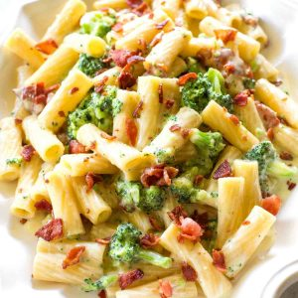
This One-Pot Bacon Broccoli Pasta comes together in less than 20 minutes. It's a great easy Italian recipe to keep in your file.

Total Time 20 minutes
Yield 4 servings

Ingredients
- 4 strips of bacon cut into chunks
- 2 cloves garlic minced
- 2 cups dry rigatoni pasta (or other small shaped pasta like penne or bowtie)
- 2 cups heavy cream
- 1 1/2 cups low-sodium chicken broth
- 1/2 teaspoon salt (and pepper to taste)
- 1/4 teaspoon crushed red pepper
- 2 cups broccoli florets
- 1/4 cup grated Parmesan cheese (more for sprinkling on top)

Instructions
- In a large saucepan, pot or Dutch oven, cook the bacon until crispy. Remove bacon from pan and drain on paper towels. Drain fat from the pot leaving about 1 tablespoon in the pot.
- Add the garlic and sautee for about 30 seconds. Add the pasta, cream, chicken broth, salt (and pepper), and crushed red pepper. Stir. Bring to a boil then reduce to a simmer. Cover and cook for about 6 minutes making sure to stir once in a while and keep noodles covered in liquid.
- Add the broccoli to the pot and cook another 5-7 minutes or until the broccoli is soft. Continue cooking until sauce is a little thicker. It will be thin and then thicken towards the end. Stir in the Parmesan and reserved bacon.
- Serve immediately and top with additional Parmesan.

Cheater Korean Beef

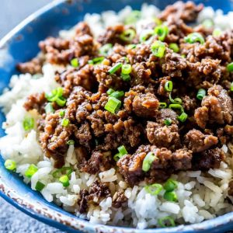
This Cheater Korean Beef is a quick version of the classic dish served over rice or in lettuce wraps for a low-carb option. You can make this Cheater Korean Beef in under 15 minutes!

Total Time 15 minutes
Yield 6 servings

Ingredients
- 1 Tablespoon sesame oil (see note)
- 1 pound ground beef
- 3 cloves garlic minced
- 1/4 cup brown sugar (add more if you like it sweeter)
- 1/4 cup soy sauce
- 1/2 teaspoon fresh ginger minced (see note)
- 1/2 - 1 teaspoon crushed red pepper depending on how spicy you like it
- 1/2 cup sliced green onions

Instructions
- Heat a large skillet over medium heat. Brown the ground beef in the sesame oil. Add the garlic towards the end of browning and cook for a couple of minutes. Drain the fat.
- Add the brown sugar, soy sauce, ginger, red pepper, and salt and pepper to taste. Simmer for a few minutes to blend the flavors. Serve over steamed rice and top with green onions. If going for a low carb option, it's great over lettuce too!

Recipe Notes
If you're like me and don't use fresh ginger that often, remember that fresh ginger freezes well. They also sell ginger in a squeeze bottle by the produce and it lasts forever.

Sesame oil adds a special something to this dish but it can be pricey so you can use another oil.

Crockpot Italian Chicken
This Crockpot Italian Chicken is one of my family favorites. Everything is thrown in the slow cooker for an easy, creamy, tasty dinner. Serve over pasta or rice!
Total Time 4 hours 5 minutes
Yield 6 servings

Ingredients
- 4 boneless skinless chicken breasts or thighs (about 1 pound)
- 2 (10.5 ounce) cans cream of chicken soup
- 1 packet dry Zesty Italian dressing mix (regular Italian is fine but I like zesty better)
- 1 (8 ounce) package cream cheese

Instructions
- Place the chicken in a crockpot and pour cream of chicken soup on top. Sprinkle dry Italian dressing mix on top. Top with cubed cream cheese.
- Cook on low in the crockpot for at least 4-6 hours. Once chicken is done you can remove it from the crockpot and shred it with two forks or a hand mixer. Stir the sauce in the crockpot and then stir in the chicken.
- If you feel the sauce is too thick you can thin it to your preferred consistency with a little milk. Serve over pasta or rice.

Recipe Notes

STOVE TOP INSTRUCTIONS
Don't have a slow cooker?
- Cook chicken in a pot with some olive oil until no longer pink. Remove from pot and shred with two forks or a mixer.
- In the pot, heat the cream of chicken soup, Italian dressing, and cream cheese over medium heat until creamy. Add milk or chicken broth to desired consistency. Stir in shredded chicken.
- Serve over pasta or rice.

Cheesy Bean Salsa Chicken

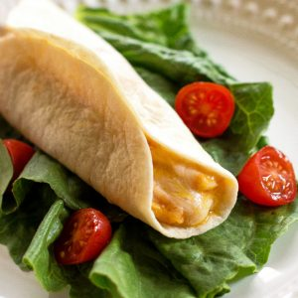
Cheesy Bean Salsa Chicken - Only 4 ingredients and delicious! All you need is chicken, salsa, refried beans, and cheese. Eat it in warm tortillas or dip with chips.
Total Time 4 hours 5 minutes
Yield 10 servings

Ingredients
- 1 lb boneless skinless chicken (I prefer thawed but you can use frozen)
- 1 (24 ounce) jar chunky salsa
- 1 (15 ounce) can refried beans
- 1-2 cups shredded cheddar cheese
- warm tortillas for serving

Instructions
- In a slow cooker, add the chicken and pour the salsa over the chicken. Cook for 4-5 hours on low or until the chicken is cooked.
- Take the chicken out and shred it with two forks, a hand mixer or stand mixer. Return the meat to the crockpot.
- Add a can of refried beans and about 1-2 cups of cheese depending how cheesy you like it. Cook on low for at least 30 minutes or until the beans and cheese are soft.
- Serve in warm tortillas. Some people like to add a dollop of sour cream inside.

Recipe Notes

STOVE TOP INSTRUCTIONS

Don't have a slow cooker? Here are the stove top instructions:
- In a dutch oven or large pot, add a tablespoon of olive oil and bring to medium high heat.
- Add the chicken and brown on both sides. Pour the salsa on top. Turn the heat down to low and cover the pot. Cook for 30-40 minutes on low or until chicken is no longer pink.
- Shred with two forks, a hand mixer, or a stand mixer with the paddle attachment.
- Return to pot and add the refried beans and cheese. Heat over medium heat for about 5-10 minutes or until beans and cheese are soft.

Chicken Noodle Skillet
This Creamy Chicken Noodle Skillet has chicken, carrots, celery, onion, and noodles all in one dinner!

Total Time 30 minutes
Yield 6 servings

Ingredients
- 1/4 cup unsalted butter
- 3/4 cup chopped carrot
- 3/4 cup diced celery
- 1/4 cup finely chopped onion
- 1/2 teaspoon minced garlic
- 1/4 cup all-purpose flour
- 3 1/2 cups chicken broth
- 1/2 cup heavy cream (milk can be substituted)
- 6 ounces wide egg noodles (about 3 3/4 cups)
- 1 1/2 cups cooked and shredded chicken (rotisserie chicken works well here)

Instructions
- In a large skillet, melt the butter over medium-low heat. Add the carrot, celery, and onion. Sautee in the butter until veggies are soft, about 5 minutes. Add the garlic and cook for about 30-60 seconds.
- Add the flour and cook for about 3 minutes or until mixture is thick. Slowly whisk in the chicken broth and cream and bring the heat up to medium-high. Add the egg noodles and cook for 5-7 minutes or until noodles are soft.
- Add the chicken to the noodles for the last minute or two of cooking to heat the chicken through. Salt and pepper to taste. Serve immediately.

Recipe Notes
Ways to make this easier:
1) Use minced garlic from a jar. It's great to have on hand.
2) Use frozen celery and carrot vegetable mix.
3) Use frozen onion. They sell diced frozen onion in bags so you can use it when you need it.
*The noodles will soak up the liquid the longer it cooks so you can add milk or chicken broth to thin it out if you need to.
*You can also use any pasta you have but egg noodles definitely cook the fastest so you may need more liquid and more time to cook if you use other pasta. Frozen egg noodles are amazing in this. They are in the frozen section next to frozen dough.

Honey Lime Chicken Enchiladas

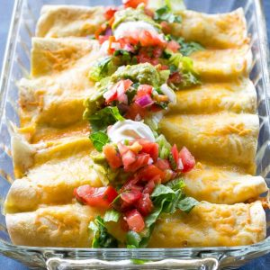
These Honey Lime Chicken Enchiladas are my go-to easy Mexican dinner for company that is also freezer friendly. If you like a sweet/savory combo, you'll love these.
Total Time 40 minutes
Yield 8 servings

Ingredients
- 1/3 cup honey
- 1/4 cup lime juice
- 1 Tablespoon chili powder
- 1/2 teaspoon garlic powder
- 2 pounds chicken, cooked and shredded (about 3-4 cups, rotisserie chicken works well here)
- 8-10 soft taco size flour tortillas
- 4 cups shredded Monterey jack or cheddar cheese
- 2 cups green enchilada sauce
- 1 cup heavy cream

Instructions
- Preheat oven to 350 degrees.
- Mix the honey, lime juice, chili powder and garlic powder together and toss with the shredded chicken. Let it marinate for 1/2 hour in a Ziploc bag or up to 8 hours.
- Spray a 9X13 pan with cooking spray. Pour enough enchilada sauce on the bottom of each baking pan to create a thin layer on the bottom, about a 1/2 cup. Fill flour tortillas with chicken and a generous amount of shredded cheese, saving about 1 cup of cheese to sprinkle on top of enchiladas.
- Mix the remaining enchilada sauce with the cream and any leftover chicken marinade (you might not need to use all of the enchilada sauce depending on how saucy you like yours). Pour sauce on top of the enchiladas.
- Bake at 350 degrees for 25-30 minutes until brown and crispy on top. Add the reserved 1 cup of cheese on top for the last 5 minutes of baking. I serve mine with sour cream, pico de gallo, cilantro lime rice, and black beans.

